## **Secondary Analysis**

### **Previous Attempts at Upgrading Systems**

While the MFGC has researched and attempted to transition away from a pre-order solution that relies so heavily on Google Sheets, they have not been successful at implementing any alternative systems. During a previous growing season, an online marketplace technology called **Arcadier** was rolled out to help streamline the flower pre-ordering process. Arcadier promises to create an online marketplace for clients that includes the following features10 :

* Search, filtering, and sorting of products
* Payment processing
* Administrative & seller dashboards
* Direct chat between buyers and sellers
* Desktop, mobile, and tablet Optimization
* Custom code and third party plug-ins



Unfortunately, there were too many technical problems that forced the MFGC to terminate the relationship and start using Google Sheets again.

In reviewing Arcadier’s rollout with Adrianne, the management within the MFGC determined that Arcadier’s solution had multiple issues related to the rollout of the system, including inadequate beta testing leading up to the rollout of the system and a lack of communication between Arcadier’s developers and the MFGC. Furthermore, Arcadier did not provide reliable customer support, which resulted in many customers not trusting the system when new bugs would be discovered during the pre-ordering and checkout process.

### **Other Flower Wholesaler’s Solutions**

**Mayesh Wholesale**

Mayesh Wholesale was founded in 1978 by Roy & Gerri Dahlson, where they started connecting flower growers with sellers by starting a wholesale distribution company. In the 1980’s, Mayesh expanded into the import business by importing flowers from places like Holland and Columbia into the United States.

During the client interview, the MFGC market manager mentioned Mayesh’s Flower Library as a feature they would like to see implemented in any potential design solution.

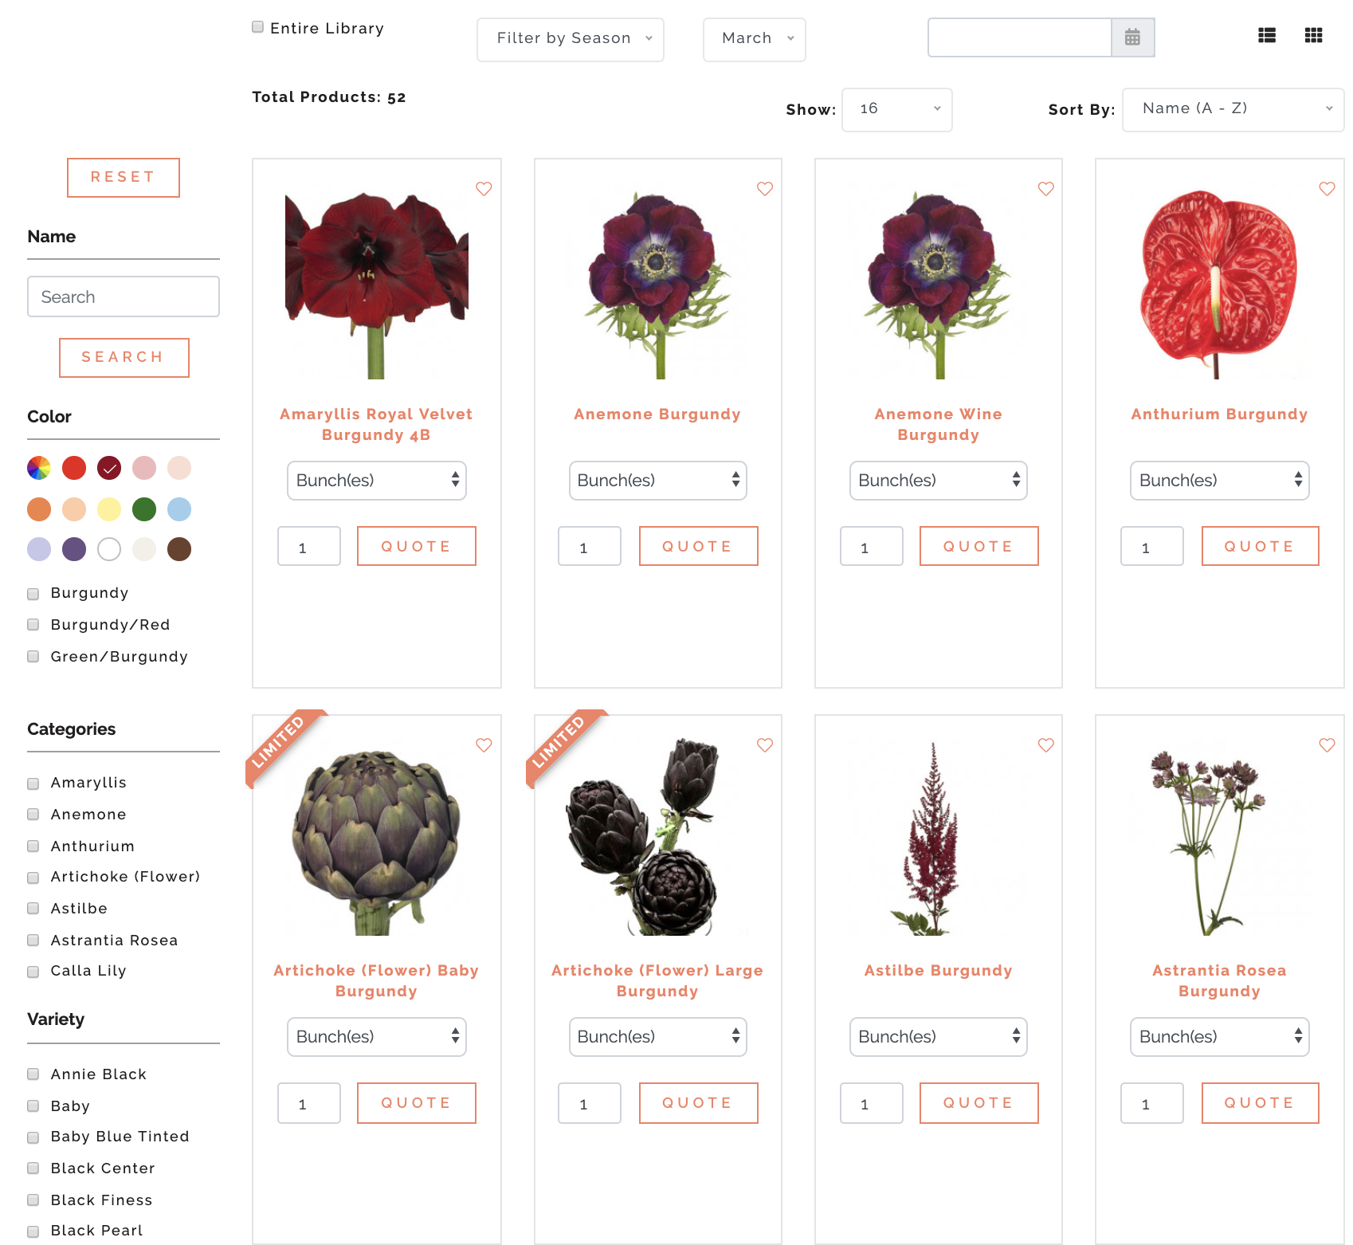

*Figure 3. Mayesh’s advanced sorting and filtering are an example of what the MFCG is looking for in a solution.*

Mayesh’s Flower Library11 provides advanced filtering and sorting using beautiful imagery of the flowers currently available for sale.

Mayesh’s Product Planner12 is another example of a feature that was mentioned during the client interview. Mayesh’s planner lets florists input their own floral arrangements recipes, which lets florists easily get a sales quote without having to individually add each flower every time they wish to order.

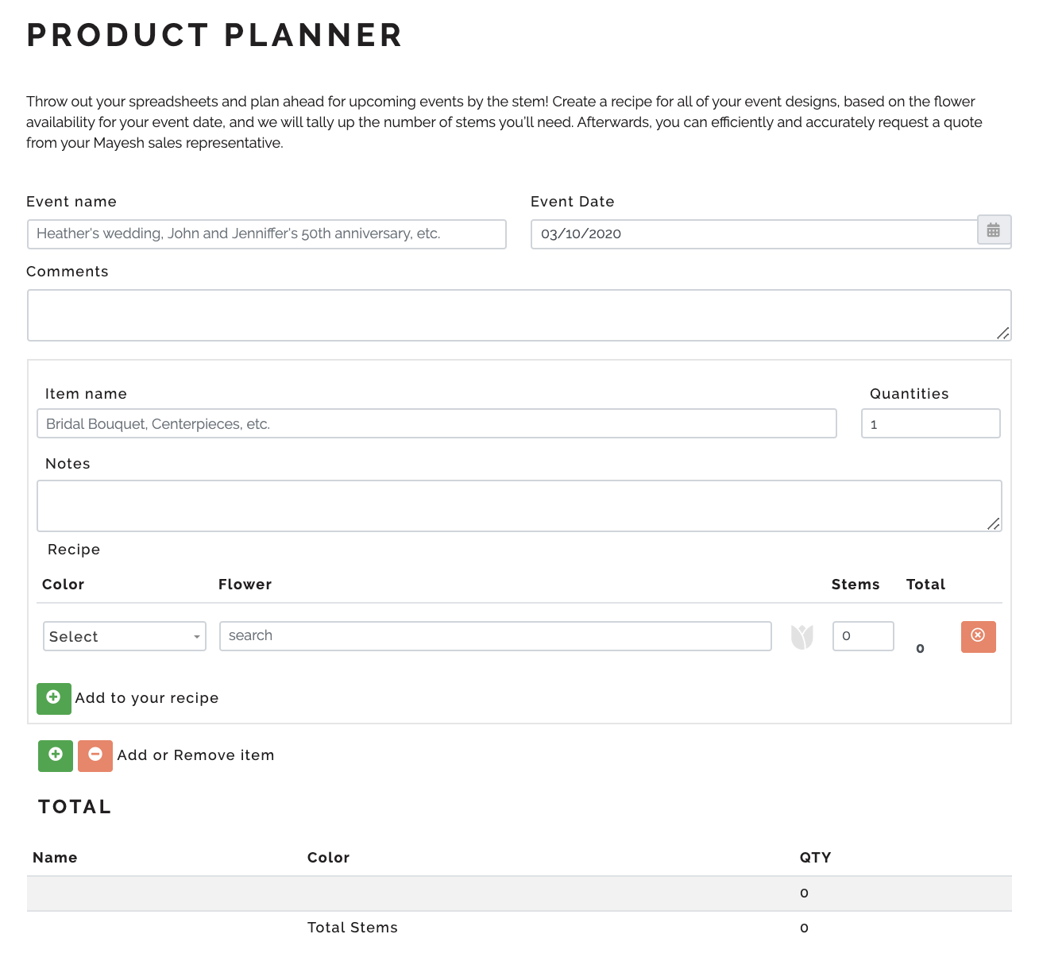

*Figure 4. Mayesh’s product planner lets florists plan their floral arrangements in advance by leveraging their advanced floral library database.*

**Seattle Wholesale Growers Market**

During the initial client meeting, the Seattle Wholesale Growers Market was mentioned as a potential source of inspiration. Known for being one of the biggest member-owned flower markets in the world, the Seattle Growers Market brings together dozens of growers to provide direct sales to both florists and consumers in the Seattle area.

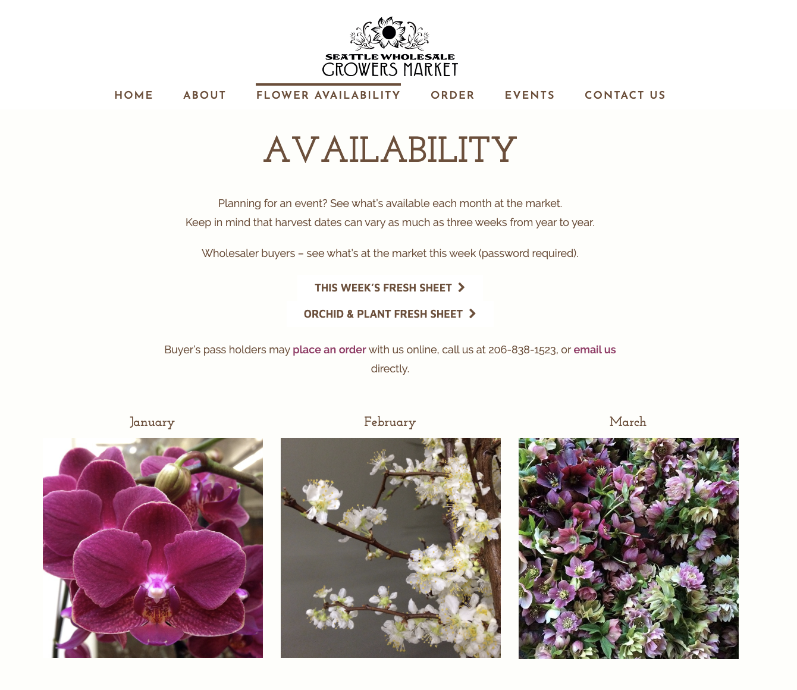

Currently, the Seattle Wholesale Growers Market provides flower availability broken down by month13. External links send potential buyers to per-date specific **Google Sheets**, which list specific information about what is actually available for the week.

*Figure 5. Seattle Market’s availability page*

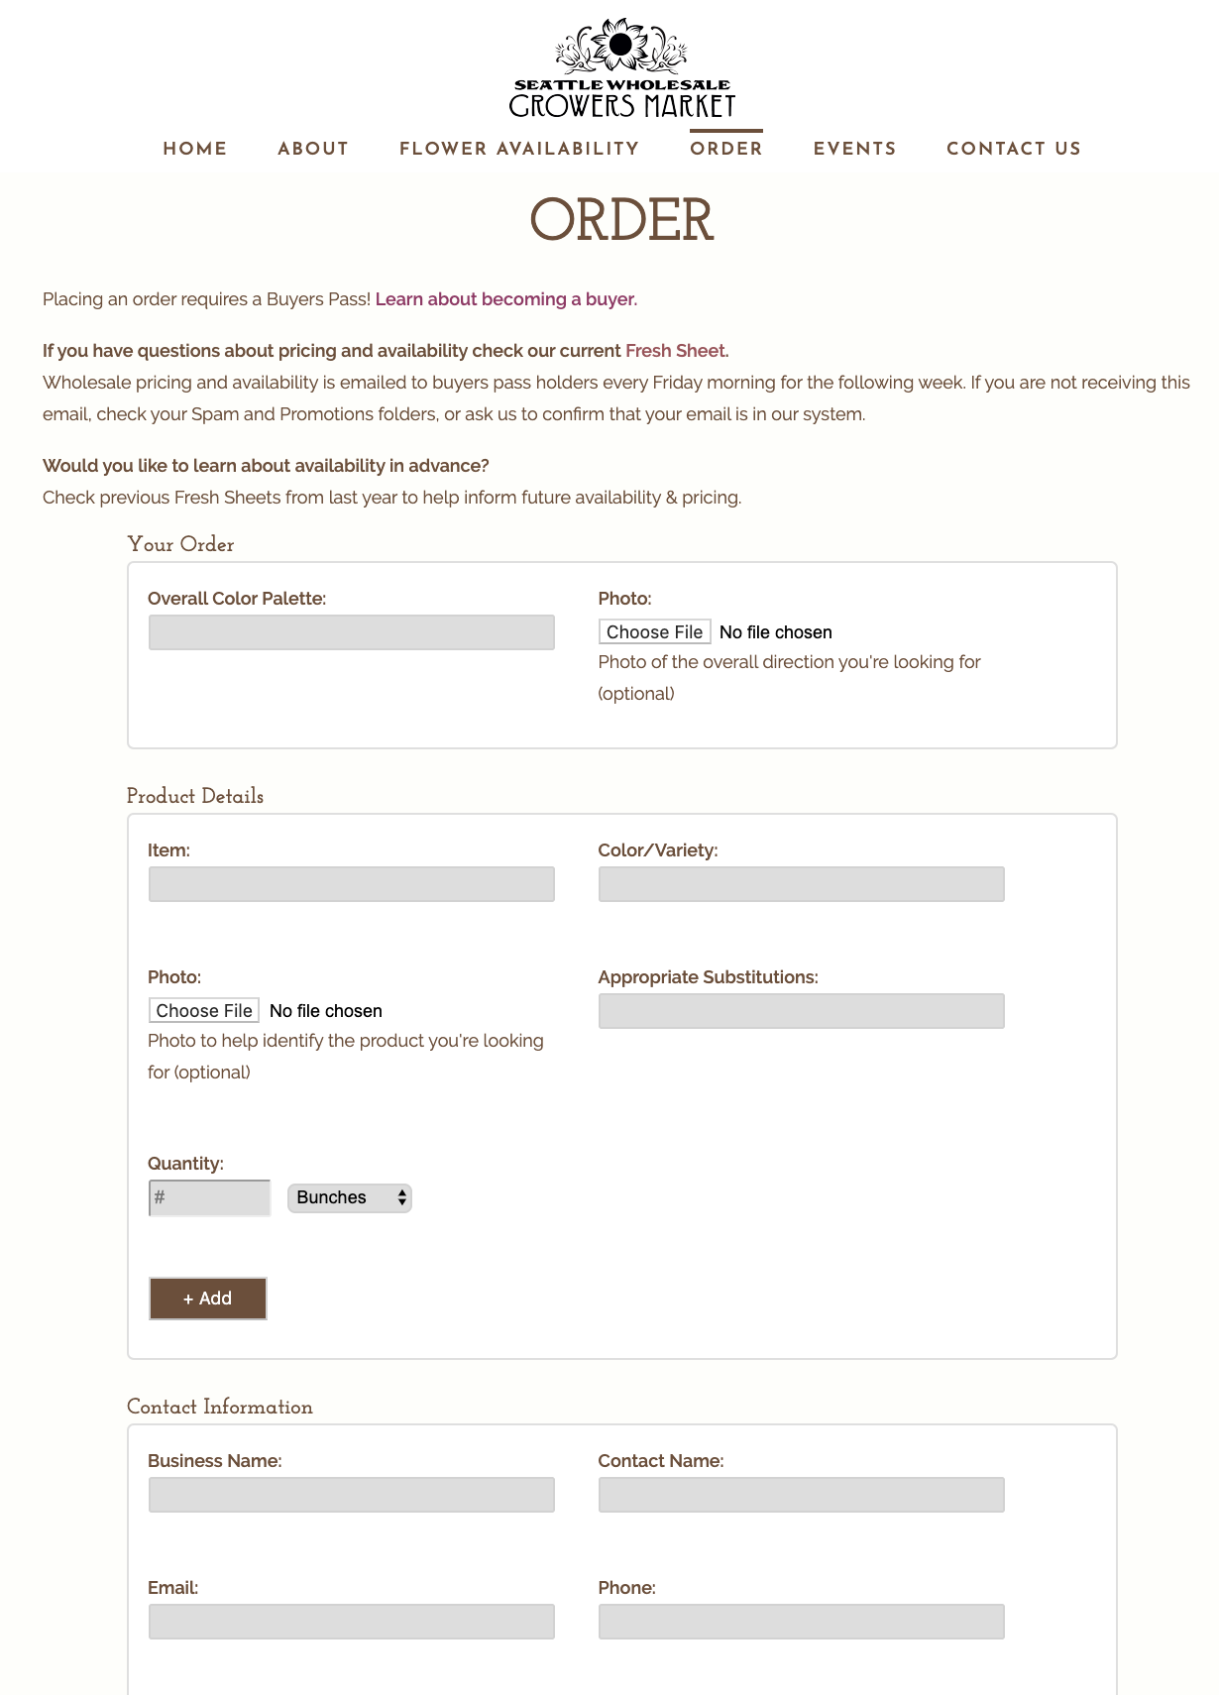

If a florist wants to place an order, they are sent to a webpage with a form that asks the user what product they specifically want to order, substitutions, and contact information14. Currently, florists are unable to pre-fill any of this information or view previous orders to help speed up the order process.

*Figure 6. Seattle Grower’s Market’s order page*

**Rooted Farmers**

Rooted Farmersis a supply chain system that helps connect lower growers with buyers by providing an inventory management system, online marketplace, customer support, and grower dashboards. Rooted Farmers is one of the few supply chain systems that is specifically marketing toward florists and growers. 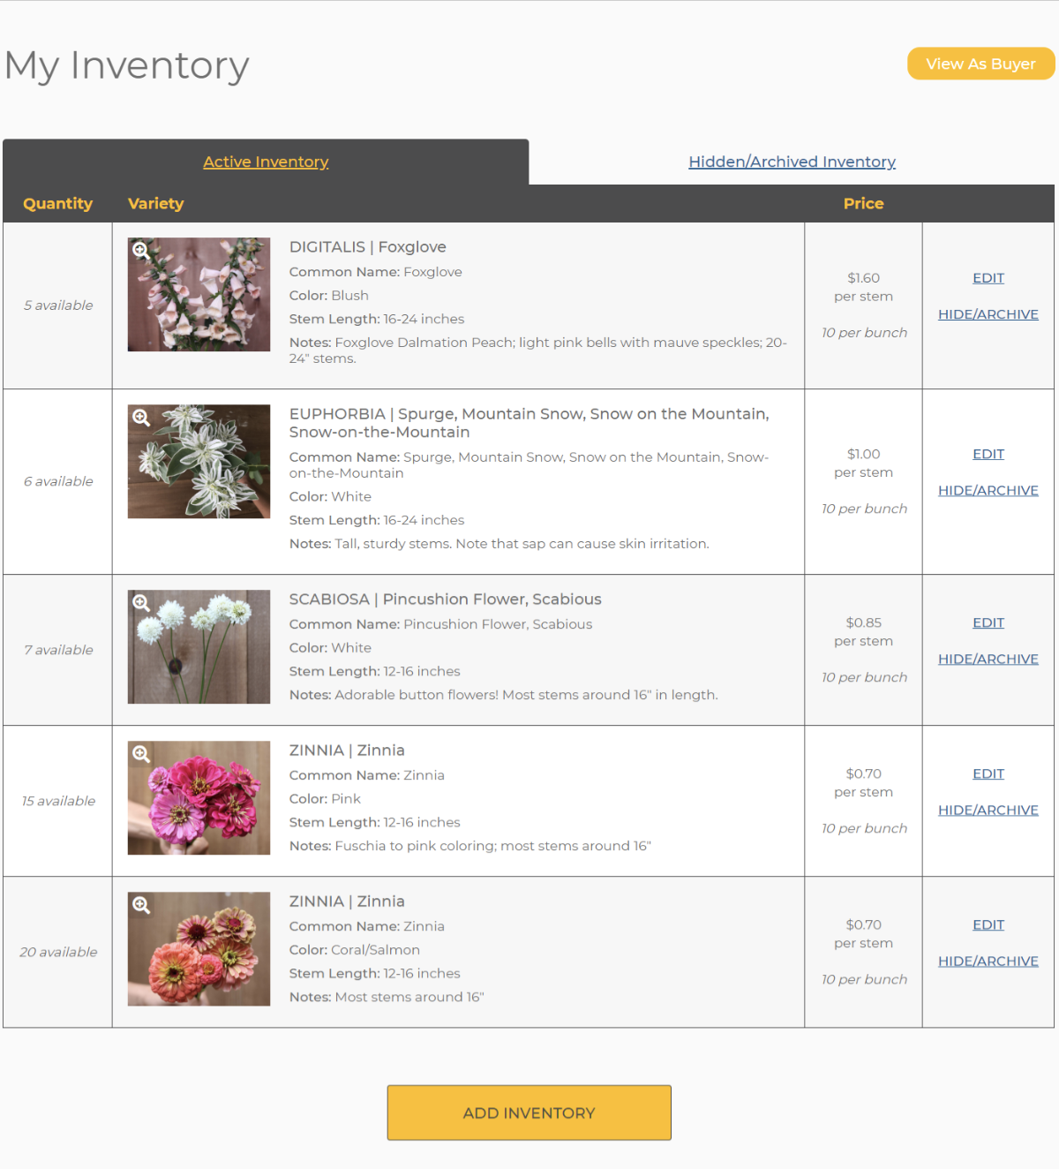

Rooted Farmers is specifically designed for flower co-operatives and exchanges by acting as a middle-man for farmers and their sellers. Each farmer’s current inventory and listings are aggregated in one area, which makes buying flowers easy.15

*Figure 7. Rooted Farm’s Inventory Interface*

For Farmers, Rooted Farmer easily lets farmers take a photo and update their inventory on the go using any mobile device, and it even offers a payment system that lets growers easily accept payments from pre-orders.16

**Local Line**

Local Line is a new online system that helps food suppliers directly market and sell their products online through a web-based portal. Local Line lets suppliers manage their inventory in real-time using any device including smartphones, tablets, and computers.

Florists looking to pre-order flowers can access an online store where they can easily sort, filter, and view inventory that is available for pick-up. Florists can choose for orders to be paid during the ordering process, or during pick-up.

Local Line offers optimized systems for three different types of users: Farmers17 looking to efficiently manage orders, customers, and inventory, Food Hubs18 looking to streamline fulfillment and make selling easier, and Food Markets19 that want to create an online market where separate vendors have the flexibility to pre-sell online.

Recently, Ann Arbor-based Argus Farm’s uses Local Line20 to coordinate pre-orders with over 200 farmers to create a wholesale food hub.21

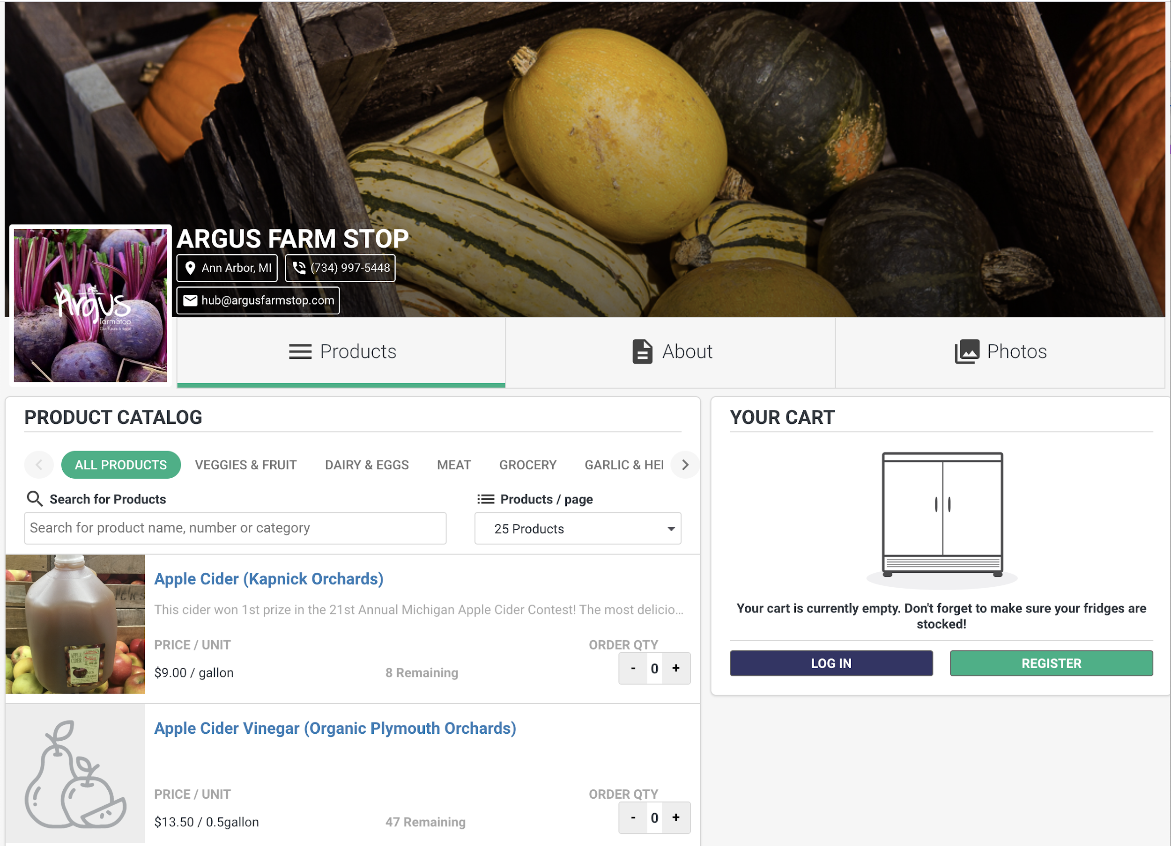

*Figure 8. Argus Farm’s Local Line Page*